MULTI-CANTEEN FOOD ORDERING SYSTEM
a mini-project report

Submitted by
DINESH S 241901028
MOHAMED SALMAN FARIS J S 241901055

in partial fulfillment of the award of the degree
of
BACHELOR OF ENGINEERING
IN
COMPUTER SCIENCE AND ENGINEERING- CYBER SECURITY

RAJALAKSHMI ENGINEERING COLLEGE, CHENNAI
An Autonomous Institute

NOVEMBER 2025

BONAFIDE CERTIFICATE
Certified that this project “MULTI-CANTEEN FOOD ORDERING SYSTEM” is the bonafide work of “DINESH S (241901028), MOHAMED SALMAN FARIS JS (241901055)”who carried out the project work under my supervision.

SIGNATURE

Ms. R. Rupmala

ASSISTANT PROFESSOR

Department of Computer Science and

Engineering (Cyber Security)

Rajalakshmi Engineering College

Chennai
This mini project report is submitted for the viva voce examination to be held on __________

INTERNAL EXAMINER EXTERNAL EXAMINER

DECLARATION
We hereby declare that the mini project report “Multi-Canteen Food Ordering and Pickup System”, submitted as part of the curriculum requirements for the Bachelor of Engineering (B.E.) degree affiliated to Anna University, is a bonafide work carried out by us under the supervision of Ms. R. Rupmala, Assistant Professor, Department of Computer Science Engineering and Cyber Security, Rajalakshmi Engineering College, Chennai.
This submission represents our ideas in our own words, and where ideas or words of others have been included, we have adequately and accurately cited and referenced the original sources.
We also declare that we have adhered to the principles of academic honesty and integrity and have not misrepresented or fabricated any data, idea, fact, or source in our submission. We understand that any violation of the above will be grounds for disciplinary action by the institution and/or the University and may also evoke penal action from the sources which have not been properly cited or from whom proper permission has not been obtained.This report has not previously formed the basis for the award of any degree, diploma, or similar title of any other University.

Rajalakshmi Engineering College, DINESH S
Chennai MOHAMED SALMAN FARIS JS
November 2025

ABSTRACT

The Multi-Canteen Food Ordering System is a web-based application designed to simplify food ordering for college canteens. The system allows students to browse menus from multiple canteens such as REC Cafe and Courtyard, place orders, and make payments online. Once the payment is confirmed, the system generates a unique order number that can be verified by the canteen staff for food pickup. This reduces manual workload, waiting time, and confusion in large institutions.
The project is implemented using PHP, MySQL, HTML, and CSS through the XAMPP environment. It includes modules for canteen selection, menu display, cart management, and order verification. The system aims to improve efficiency, transparency, and the overall user experience in campus food management.
The main objective of this project is to provide a simple, user-friendly platform where students can easily browse available foods, canteens and can order through website.

Keywords: PHP, MySQL, HTML, Multi-Canteen Food Ordering System, Database Management, Java JDBC,XAMPP and CSS.

ACKNOWLEDGEMENT

We like to convey our sincere appreciation to all who have supported and mentored us during the successful completion of this project work.

We express our profound gratitude to Mr. Benedict J.N., Associate Professor (SG) and Head of the Department of Computer Science Engineering and Cyber Security at Rajalakshmi Engineering College, for furnishing us with essential resources, support, and an enabling environment to execute this project.

We express our profound gratitude to Ms. R. Rupmala, Assistant Professor in the Department of Computer Science Engineering and Cyber Security at Rajalakshmi Engineering College, for her unwavering support, invaluable insights, and collaboration throughout our endeavor.

We would like to convey our gratitude to our faculty members and colleagues for their valuable feedback and encouragement.

We express our gratitude to our families and friends for their steadfast support, patience, and encouragement, which were instrumental in the effective execution of this seminar.

DINESH S
MOHAMED SALMAN FARIS J S

TABLE OF CONTENTS
CHAPTER NO. | TITLE | PAGE NO
 | ABSTRACT | i
 | ACKNOWLEDGEMENT | ii
 | LIST OF FIGURES | iv
1 | INTRODUCTION | 1
1.1 | Project Overview | 1
1.2 | Scope of the work | 1
1.3 | Problem Statement | 2
1.4 | Aim and objectives of the project | 2
2 | SYSTEM SPECIFICATIONS | 3
2.1 | Hardware Specifications | 3
2.2 | Software Specifications | 4
3 | MODULE DESCRIPTION | 5
3.1 | Canteen Selection Module | 5
3.2 | Menu Display Module | 5
3.3 | Cart Management Module | 5
3.4 | Order Generation Module | 5
3.5 | Admin Module | 5
4 | CODING | 6
5 | SCREENSHOTS | 8
5.1 | Home Page | 8
5.2 | Menu Page | 8
5.3 | Cart Page | 9
5.4 | Order Confirmation Page | 10
6 | CONCLUSION AND FUTURE ENHANCEMENT | 11

LIST OF FIGURES
FIGURE NO. | TITLE | PAGE NO
1.1 | Project Overview | 1
1.2 | Scope of the work | 1
1.3 | Problem Statement | 2
1.4 | Aim and objectives of the project | 2
2.1 | Hardware Specifications | 3
2.2 | Software Specifications | 4
3.1 | Canteen Selection Module | 5
3.2 | Menu Display Module | 5
3.3 | Cart Management Module | 5
3.4 | Order Generation Module | 5
3.5 | Admin Module | 5
5.1 | Home Page | 8
5.2 | Menu Page | 8
5.3 | Cart Page | 9
5.4 | Order Confirmation Page | 10

CHAPTER 1
INTRODUCTION
  - PROJECT OVERVIEW
The Multi-Canteen Food Ordering System is a web-based application designed to streamline the food ordering process within educational institutions that have multiple canteens. Traditionally, students wait in long queues to place and collect their food orders, resulting in time wastage and inefficiency. This project digitalizes the entire process by allowing users to browse canteen menus, add items to a cart, and place orders online. Each order generates a unique order number which the canteen staff can verify during food collection. This system ensures faster service, improved management, and convenience for both students and staff.
  - SCOPE OF THE WORK
The scope of this project is to automate food ordering within a college campus by integrating multiple canteens under a single webapplication.
- Easy selection between multiple canteens (e.g., REC Cafe, Courtyard).
- Real-time menu updates and item availability.
- A simple and secure order management process.
- An admin panel for managing menu items, prices, and order data.
- A verification system using unique order IDs for smooth pickup.
- The project can later be expanded to include QR verification, digital payments, and order tracking features.

  - PROBLEM STATEMENT
In the existing manual system, students physically visit the canteen to place and collect their orders. During peak hours, this results in long queues, miscommunication, and delays. Managing multiple canteens also becomes difficult due to uncoordinated operations and manual record-keeping.
Hence, there is a need for an online system that allows users to place orders quickly, reduces waiting time, and helps canteen staff handle multiple orders efficiently.
1.4 AIM AND OBJECTIVES OF THE PROJECT
Aim:
To design and develop an online food ordering system for multiple canteens within a college campus that simplifies food ordering, reduces manual effort, and ensures fast service.
Objectives:
- To create a user-friendly web application for ordering food online.
- To allow users to choose from multiple canteens and browse respective menus.
- To implement cart management and order summary functionalities.
- To generate a unique order number for easy verification.
- To provide an admin module to update menu and monitor orders.
- To improve the overall efficiency of the canteen management process.

CHAPTER 2
SYSTEM SPECIFICATIONS
2.1 HARDWARE SPECIFICATIONS
COMPONENT | SPECIFICATION
Processor | Intel i3
Memory Size | 4GB (Minimum)
HDD | 1 TB (Minimum)

The system requires an Intel i3 processor to ensure smooth execution of the Java application and MySQL queries without lag. The 4 GB RAM supports multitasking, such as running the database server, and the website simultaneously. A 1 TB hard disk provides sufficient storage for MySQL databases, images, and backup files. These configurations ensure stable performance and reliability during development and execution of the Multi Canteen Food Management System.

2.2 SOFTWARE SPECIFICATIONS
COMPONENT | SPECIFICATION
Operating System | WINDOWS 10
Front – End | JAVA
Back - End | MySQL
Language | JAVASCRIPT, SQL,HTML,CSS
Database Connectivity | JDBC,PHP
Windows 10 is used as it provides compatibility with Java and MySQL and offers a stable environment for desktop development. Java is chosen for the front-end because it supports cross-platform GUI creation using Swing and is well-suited for object-oriented design. MySQL serves as the back-end due to its open-source nature, high reliability, and ability to handle relational data efficiently. Java, SQL, HTML and CSS together ensure smooth communication between application logic and data management. PHP and JDBC (Java Database Connectivity) is used as the middleware to connect Java with MySQL, providing secure, fast, and easy database interaction for data retrieval and updates.

CHAPTER 3
MODULE DESCRIPTION
1. CANTEEN SELECTION MODULE
Allows the user to select from available canteens (REC Cafe, Courtyard). Each canteen has its own menu and item list.
2. MENU DISPLAY MODULE
Displays available food items for the selected canteen, along with price, image, and “Add to Cart” option.
3. CART MANAGEMENT MODULE
Users can add, update, or remove items from the cart, and the total amount is calculated dynamically.
4. ORDER GENERATION MODULE
When the user confirms an order, a unique order ID is generated. This ID can be shown to the canteen for food collection.
5. ADMIN MODULE
Admins can add new food items, update prices, or delete items from the menu.
They can also monitor order details and manage canteen information.

CHAPTER 4
SAMPLE CODING
Technologies Used:
- HTML/CSS: For front-end design and layout.
- PHP: For server-side logic and database connectivity.
- MySQL: For managing data related to canteens, menus, and orders.
- XAMPP: For running Apache and MySQL locally.
<?php
include 'db.php';
$canteen_id = $_GET['canteen_id'];
$query = "SELECT * FROM menu_items WHERE canteen_id = $canteen_id";
$result = mysqli_query($conn, $query);

while ($row = mysqli_fetch_assoc($result)) {
echo "<div class='menu-card'>";
echo "<imgsrc='".$row['image']."' alt='".$row['item_name']."'>";
echo "<h3>".$row['item_name']."</h3>";
echo "<p>₹".$row['price']."</p>";
echo "</div>";
}
?>

CHAPTER 5
SCREEN SHOTS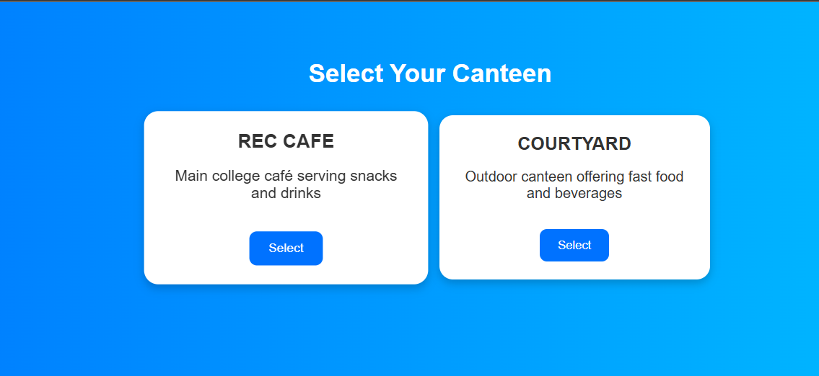
Fig 5.1 Home Page
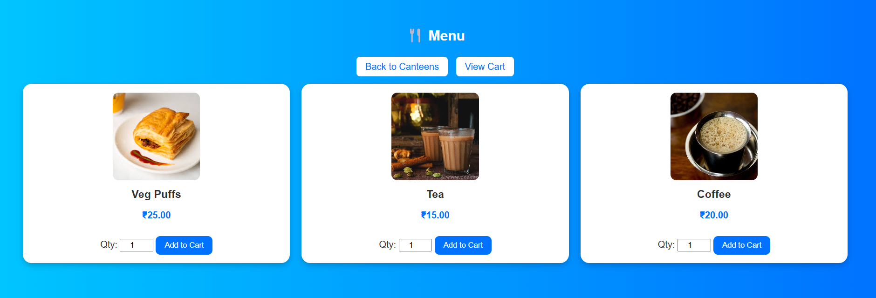

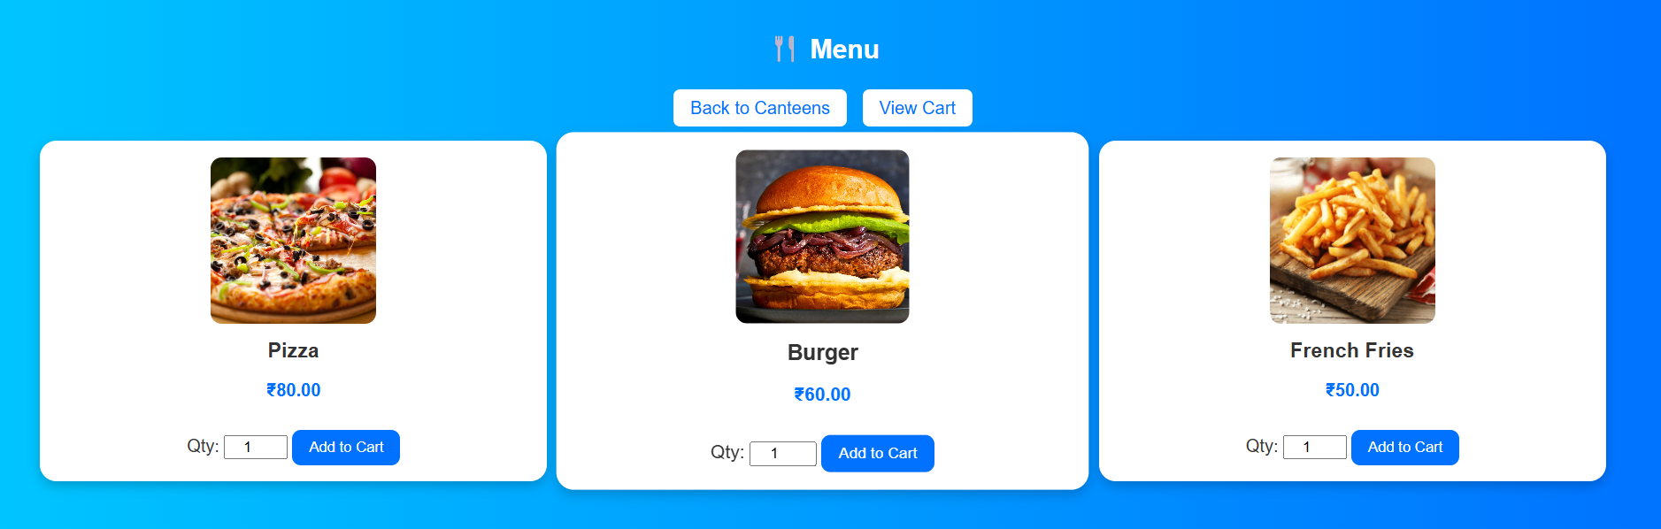
Fig 5.2 Menu Page
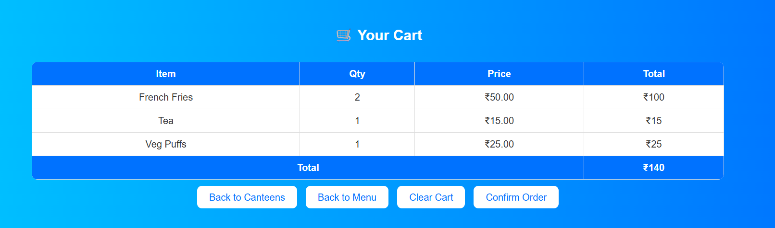
Fig 5.3 Cart Page
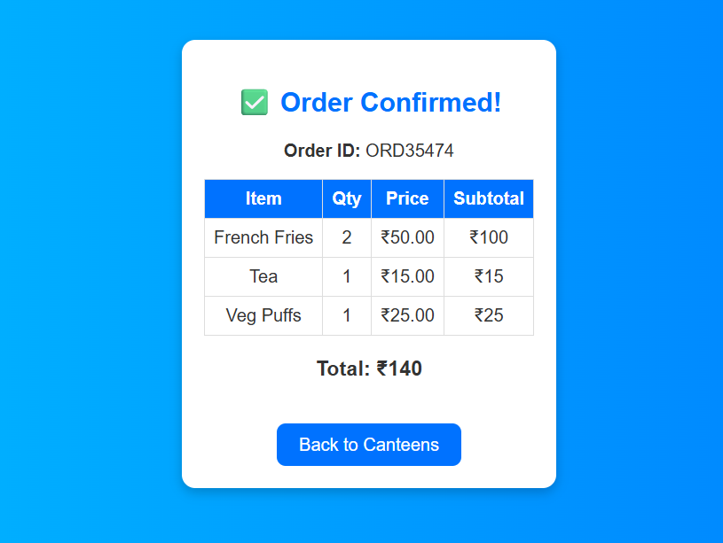
Fig 5.4 Order Confirmation Page

CHAPTER 6
CONCLUSION AND FUTURE ENHANCEMENT
The Multi-Canteen Food Ordering System successfully simplifies food ordering across multiple canteens. It provides a seamless user experience, reduces waiting times, and improves coordination between students and canteen staff. The use of PHP and MySQL ensures reliability and easy scalability for future improvements.
- Integration of online payment gateways (UPI, Debit/Credit cards).
- QR code generation for each order to automate pickup verification.
- Live order tracking system.
- Mobile application version for Android/iOS platforms.
- Notification system (SMS or Email) for order status updates.

REFERENCES
https://www.w3schools.com/java/
https://www.w3schools.com/sql/
https://www.geeksforgeeks.org/java-swing/
https://www.tutorialspoint.com/mysql/index.htm
https://www.javatpoint.com/java-jdbc
https://www.codecademy.com/learn/learn-java

